Parte 3

1 What are you cocking?
- Yes, I am

- I am cocking a cake
- What are you doing?

2 Are you sick?
- How?

- No, I am not sick
- I want a pizza

3 We sell a awesome clothes
- Where?
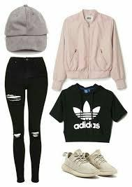
- She is my mom
- Are you ready


4 Is he the brother of samantha?
- Yes, she is
- No, he is not
- Samantha is a beautiful person

5 María is the most intelligent person of the school
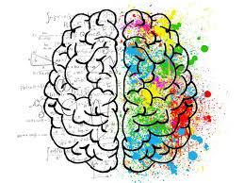
- Who?
- My mom is a awesome person
- Yes, she is the most intelligent person

