PRUEBA SABER 11

PARTE 3

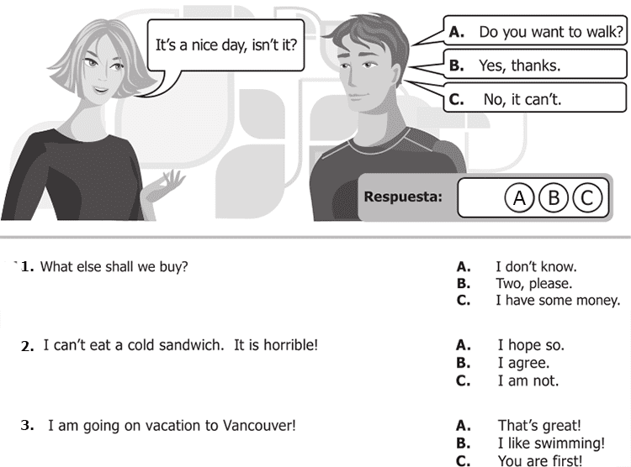

1. **A** 2. **B**  3. **A**

**4 .** It rained a lot last night! A. Did you accept?

B. Did you understand?

**C. Did you sleep?**

5. Grandma, shall I hold those bags for you? A. I'm not afraid!

B. What's the matter?

**C. That's fine.**

6. How much is that umbrella? A. Anything else?

**B. 50 dollars.**

C. Cash only!

7. Can I use your printer? A. Just a minute

**B. Do it this way**

C. Think about it

8. Who's the girl?  **A. She's my sister**

B. Yes, she is

C. That's ok

9. Do you know Peter? A. Which?

**B. who?**

C. What?

10. Can you pass me the salt? A. Here you are

B. I like it

**C. It's all right**

**Continue next page**

11.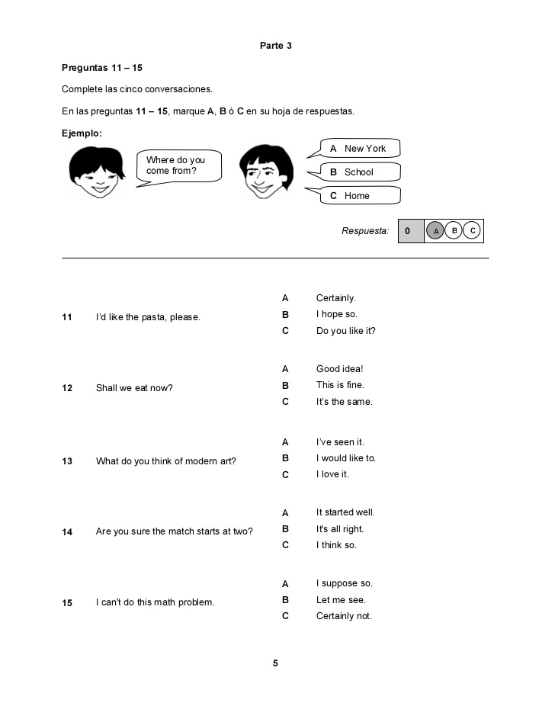

11. **C** 12. **A**  13. **C** 14. **C** 15. **B**