**Prueba 1 (**estructura de prueba 3**)- Danna V. Segura 11-03**

1. My grandmother just died

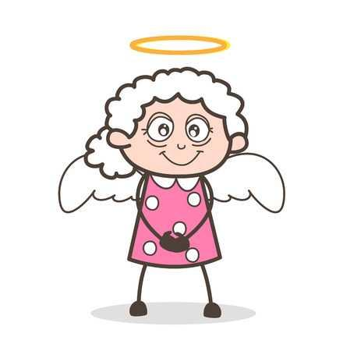

1. I'm so sorry
2. Oh this is great!
3. I love pizza

2. I have hungry!

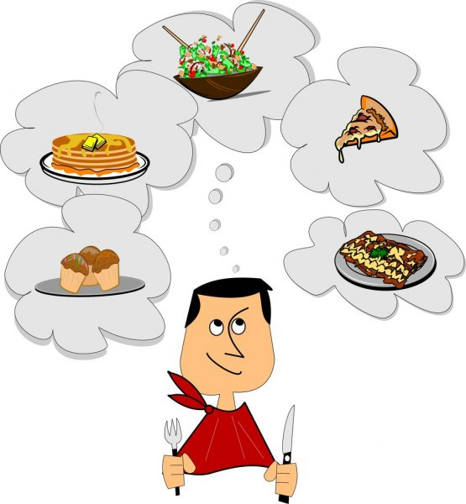

1. I'm bored
2. Me too
3. Call me!

3. What do you want to do today?

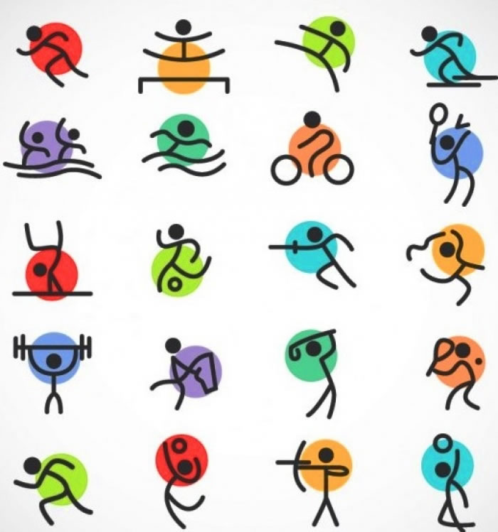

1. Let's go to the park
2. My mother is beautiful
3. The sun shines

4. How is Angela?

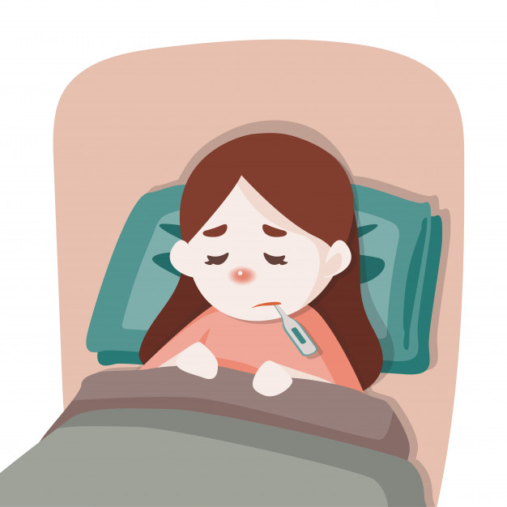

1. I want to sleep
2. In the museum
3. She is sick

5. Who wrote you?



1. Don't do it this
2. Is nobody!
3. I'm fine